PHP Scheduler
User Guide
By Vladimir Vassiliouk

- Introduction
The PHP Scheduler was created to improve the way we organize and execute the various scripts we currently have running in crontab. Instead of having scripts for each interval randomly placed within a crontab file, the Scheduler allows us to keep all scripts organized in an easy to use web interface. The Scheduler also grants us more flexibility by allowing us to execute scripts in intervals smaller than 1 minute unlike crontab which starts a series of scripts at the beginning of the minute and may overload the system.

- Web Application (http://phpprd/ALL/scheduler/)
  - Scripts Admin ([prd|tst]all_Cscriptsadmin.php)
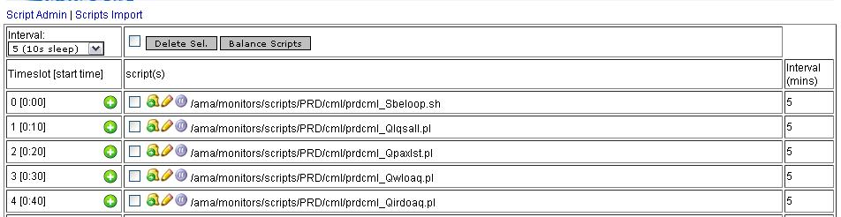This page allows you to visualize available intervals, their timeslots, and the scripts assigned to each timeslot. You can also delete, add, edit, move, and disable/enable individual scripts within each interval.
Note: The web application is restricted to certain PHP users. Each user has a unique username and password.
- The “Interval” select box allows you to see and select the currently configured intervals. Upon selecting an interval the page will reload with that interval’s timeslots and scripts if any have been added.
- In the middle top column contains a check-all checkbox, a delete selected button, and a balance scripts button.
  - The checkbox will select all scripts in all timeslots, and unselect when unchecked.
  - The “Delete Sel.” button will delete all scripts selected after confirming a prompt.
  - The “Balance Scripts” button will balance the scripts so that all time slots are filled in proper order. NOTE: For best performance it is recommended to maintain a balance of scripts across timeslots.
- The first column on the left shows the timeslot and its corresponding start time relative to the interval in min:sec format
  - The amount of timeslots each interval has is calculated based on the interval and sleep time between scripts which was defined upon creation of the interval. For example, a 1 minute interval with a set sleep time of 1 second will have 60 time slots. Each timeslot can hold any amount of scripts, which will be executed in series.

    - Adding Scripts
In the first column on the left, the icon will call a prompt which allows you to enter one command to be added to that particular timeslot:
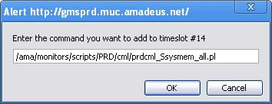
Enter the command exactly as you would like it to be run within a shell. The script should only be one executable file, with the full path. Note: All STDOUT will be redirected to /dev/null upon execution. If you want to log errors within the Scheduler’s log files, then do not redirect STDERR. Note: For critical scripts, we recommend that a notification system within the actual script is implemented for faster error visibility.

    - Editing, Deleting and Moving Scripts
The middle column lists all scripts available for each timeslot, and allows you to delete, move, edit and disable/enable each one.

Editing:
The icon gives you a prompt with the selected script’s commands to allow you to edit it however you please.
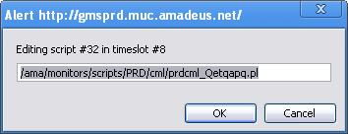

Deleting:
To delete a script or many scripts just check the checkbox next to each script you would like to remove. After you have finished selecting the scripts, just click the “Delete Sel.” button on top.

Moving:
The icon next to the checkbox is the move script icon:. This icon will give a prompt asking to enter a new timeslot where you would like to move the script to. Note that you are limited to the available timeslots only, which are displayed within the parenthesis. For example: here we are moving a script in a 5 minute interval which is set to have 10 seconds of sleep time in between timeslots, therefore this interval has a maximum of 30 timeslots, so you are limited to timeslots between 0 and 29.
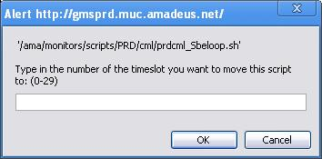

Disabling/Enabling:
Incase a script has an issue which needs to be fixed; we have implemented a feature to allow us to temporarily disable the rogue script from being executed during timeslot execution. The icon next to the edit icon will allow you to temporarily disable execution of any particular script. If a script is already disabled this icon will look like this: and it will enable the script when you click it. Any script which is disabled will also appear in a grey font color.
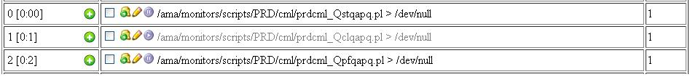

  - Import Scripts ([prd|tst]all_Cscriptsimport.php)
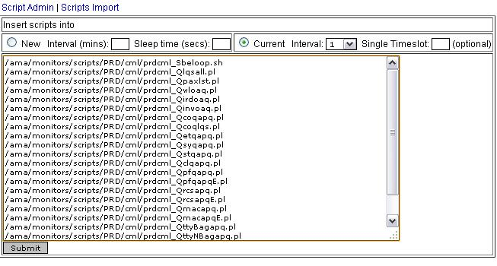
The Import Scripts page allows you to massively import scripts into New, or Currently configured Intervals, and optionally into a single timeslot.

    - Creating a new interval and importing scripts
To create a new interval select the “New” option, fill out the interval value in minutes and your desired sleep time between timeslots in seconds, then enter the scripts you wish to import into this interval’s timeslots and click Submit. Each new line is considered an individual “script”. Each script should be one executable file with the full path; please do not chain commands. The scripts will be automatically allocated to timeslots within the interval. The interval in seconds divided by the sleep time is the amount of time slots this interval will have for running scripts in.

    - Importing scripts into currently configured intervals
The “Current” option allows you to massively import scripts into a currently configured interval and optionally into a single timeslot. To import, select one of the already configured intervals in the select box, and optionally, enter the number of a timeslot to which you want all of your scripts to be imported. WARNING: Doing so will unbalance the scripts in timeslots which may impact performance. If no timeslot is defined, the scripts you enter will be automatically allocated to the timeslots containing the least amount of scripts in order from first to last. Each line in the textbox is considered a “script”, meaning each line will be executed the way it is typed. Each script would be the full path to an executable file. All STDOUT will be redirected to /dev/null upon execution. Do not redirect STDERR if you want to log errors in the Scheduler’s logs.

- Logs
When the [prd|tst]all_Sexecscripts.php wrapper runs, two logs are created in /ama/{phpprd|phptst}/log/ALL: “[prd|tst]all_Sexecscriptsinfo[interval].log” and “[prd|tst]all_Sexecscriptserr[interval].log”.

  - The Info log [prd|tst]all_Sexecscriptsinfo[interval].log
Within this log each command for each timeslot that is ran is stored. This log also shows the elapsed time in milliseconds it took to finish running all scripts in the timeslot, and the time it slept between each timeslot which is calculated by the desired sleep time minus the elapsed time.
> tail -f prdall_Sexecscriptsinfo1.log
2008-10-17 18:55:16 INFO: Sleeping for 0.98553895950317
2008-10-17 18:55:17 INFO: Starting timeslot #15
2008-10-17 18:55:17 INFO: exec(170) /ama/phpprd/scripts/PRD/cml/prdcml_QrcsapqE.pl
2008-10-17 18:55:17 INFO: Ended timeslot #15 elapsed time: 0.0040299892425537
2008-10-17 18:55:17 INFO: Sleeping for 0.99597001075745
2008-10-17 18:55:18 INFO: Starting timeslot #16
2008-10-17 18:55:18 INFO: exec(171) /ama/phpprd/scripts/PRD/cml/prdcml_QpfqapqE.pl
2008-10-17 18:55:18 INFO: Ended timeslot #16 elapsed time: 0.0049989223480225
2008-10-17 18:55:18 INFO: Sleeping for 0.99500107765198
2008-10-17 18:55:19 INFO: End: execscripts.php
The number in parenthesis next to exec is the id of the script it is running from the database.

  - The Error log [prd|tst]all_Sexecscriptserr[interval].log
Because scripts are launched in the background, we cannot wait to capture the return value for each script. To combat this, all STDERR output is captured in a temporary log file (/tmp/prdall_tmpexecscriptserr[interval].log) for each interval every time the ‘/ama/{phpprd|phptst}/scripts/ALL/[prd|tst]all_Sexecscripts.php’ wrapper runs. Errors captured in the temporary error log are written to this error log file at the end of each run. The error log entries include the script’s start and end time, and all STDERR captured during that time.

Sample output:
> tail -f prdall_Sexecscriptserr1.log
2008-10-22 17:51:54 ERROR: Errors captured while executing scripts for interval 1 between 17:51:50-17:51:54
--START--
sh: test2: command not found
sh: test3: command not found
--END--

- Automation
To run the scripts on a machine, the [prd|tst]all_Sexecscripts.php script has to be executed with the interval argument which tells it where to get timeslots, desired sleep time, and scripts. To automate this, it is recommended to use crontab or BMC Control-M.

Sample Crontab entry example for 1 minute interval scripts:
*/1 * * * * interval=1; /ama/{phpprd|phptst}/scripts/ALL/prdall_Sexecscripts.php $interval 2>/tmp/prdall_tmpexecscriptserr${interval }.log
In this example, crontab will execute prdall_Sexecscripts.php every minute with the ‘1’ argument, redirecting all STDERR to a temporary error log.

[prd|tst]all_Sexecscripts.php will load all timeslots in ascending order for the interval and begin executing scripts assigned to each timeslot. It will sleep in between timeslots. To ensure that scripts do not overrun the interval time, the sleep value changes by calculating the desired sleep time amount minus the elapsed time it took to execute all scripts in the previous timeslot.

For example, this timeslot ran for a 1 minute interval which has the sleep time set as 1 second:
2008-10-17 18:55:18 INFO: Starting timeslot #16
2008-10-17 18:55:18 INFO: exec(171) /ama/{phpprd|phptst}/scripts/PRD/cml/prdcml_Qpaxlst.pl > /dev/null
2008-10-17 18:55:18 INFO: Ended timeslot #16 elapsed time: 0.0049989223480225
2008-10-17 18:55:18 INFO: Sleeping for 0.99500107765198
Since the execution of all scripts in that timeslot took 0.0049989223480225 of a second, the sleep time is now 0.99500107765198 of a second.

While executing scripts, information such as start and end times for each time slot and which scripts were executed is being logged in the info log, and any errors captured will be written to the error log at the end of each run of the wrapper.

- Glossary
Interval – An integer value in minutes which has assigned timeslots, sleep time and scripts within the scheduler database. This value also represents the maximum allowed time for all scripts to run in.
Script – A Linux command or set of Linux commands which are executed in the background on the Linux node on which the scheduler resides
Sleep time – An integer value, which represents the maximum duration of the pause in between timeslots during script execution. This value is modified during run time by subtracting the elapsed time of execution of scripts within each timeslot to avoid overrunning the interval time.
Timeslot – An integer value that represents a point in time within an interval. Timeslots can have any amount of scripts assigned to them. When a timeslot is being executed, the scripts are executed in series without pause. After execution of all scripts in a timeslot, there is a pause for the sleep time defined for the interval, minus the duration of execution of the scripts in the timeslot. This ‘dynamic’ interval compensates for any system lag, and ensures that each timeslot is executed on time.

